**FLIGHT RESERVATION SYSTEM**

* **Joy Francesca Machado**

**- Mounika Dantuluru**

* **Shivani Gowrishankar**

**PROJECT STATEMENT**

The problem that we have tried to solve is to build an airline reservation system. The Airline Reservation System project is an implementation of a general Airline Ticketing website like Kayak, where the customers can search the availability of flights offered by various airlines to desired location and their prices. The features to be covered by the system are user-profiles (the user can create an account with the website), where the user can view his/her personal details given during account creation, booking history, ‘Buy’ and ‘Cancel’ option to purchase tickets and cancel already purchased tickets. The user can input the source location, destination location, arrival date and destination date and view search results to book tickets according to his travel plans. The user can write reviews and rate the airlines about his experience during a journey. The user can also view other user’s comments and rating of an airline just before buying a ticket. The user also gets points for every purchase and can also purchase tickets using the points.

**PROPOSED SOLUTION**

We plan to implement the project by creating a profile page for the user. From the profile page of the user, the user can search the availability of tickets. This search query is sent to the web services and the data is fetched by using an external API which returns the data in JSON format. Once the data has been fetched it will be displayed in the search results page. The user can choose any one of the search results and can book a flight. While booking flight, the user will also be able to view the rating and comments on the airline the user has chosen to travel with.

The user also has the option of using either dollars or frequent flier miles while booking a flight. The frequent flier miles are accumulated for every user, when he/she purchases a ticket using dollars. The accumulated frequent flier miles can be redeemed whenever needed and used to book a flight.

The user can rate and review an airline that he/she had travelled with. The user can also change the rating and review after given, if he/she changes his/her mind.

The user profile page displays the current bookings made by a user and also allows the user to cancel a booking or view the itinerary of a booking.

**ARCHITECTURE**

The initial part of the project involved fetching data from the external API. The API that was used was ‘Sabre Dev Studio’. The data obtained from the API was in JSON format and were parsed using a server side web service client to display the search results. The data were parsed using JSON.simple toolkit- a java toolkit for JSON to decode JSON text.

Once the user selects an itinerary to book and enters the passenger details, the itinerary and passenger details are persisted into the database using JPA.

The persisted data is displayed using JSP to the user.

The user admin is created and can create, delete, update and read all user profiles. JWS was implemented to handle the use cases of user admin.

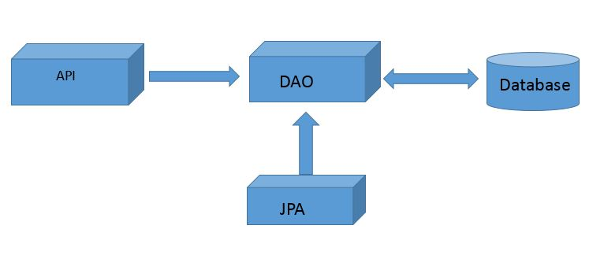

**APIs**

The External API that we have used is ‘Sabre Dev Studio’ API to display the flight search results.